SIMATS ENGINEERING (SAVEETHA SCHOOL OF ENGINEERING)
Department of Computer Science and Engineering

ASSESSMENT TOOL 1 – ANALYTICAL PROBLEM SOLVING

Course Code: | CSA06 | Course Title: | Design and Analysis of Algorithms
CO Assessed: | CO2 – Manipulation (BL1, BL2, BL3) | Assessment: | Assessment Tool 1 – Analytical Problem Solving
Weightage: | 40% of CIA | Total Marks: | 100
CO2 Statement: | Apply Brute Force technique to solve sorting, searching, Closest-Pair and Convex-Hull problems  (BL1, BL2, BL3)
Student Name: | M. Ranjith Kumar Reddy | Reg. No.: | 192524172
Section / Batch: | Slot A | Date: | 29/07/2026

Instructions to Students
- Answer ALL questions. Total Marks: 100.
- Analyze each problem carefully before applying the appropriate Brute Force technique.
- Clearly show all intermediate steps, comparisons, iterations, and logical reasoning used in solving the problems.
- Apply suitable algorithms for sorting, searching, Closest-Pair, and Convex-Hull problems wherever required.
- Justify the correctness and efficiency of the proposed solution using appropriate complexity analysis.
- Use diagrams, tables, or stepwise illustrations wherever necessary for better explanation.
- Maintain neat presentation, proper algorithmic notation, and structured analytical reasoning throughout the answers.

Question Type | Focus Area | Questions | Marks
Application-Based Questions | Apply Brute Force techniques for sorting, searching, Closest-Pair and Convex-Hull problem analysis | Q1 Q2,Q3 | 40 60 (2X30)
 | GRAND TOTAL: | 100 Marks

SECTION A – APPLICATION BASED QUESTIONS
Selection Sort – Repeated Minimum Elements
Apply the Brute Force technique using Selection Sort on the dataset [12, 5, 7, 5, 18, 9]. Clearly interpret the problem and explain how Selection Sort handles repeated minimum values. Perform the sorting step-by-step and show the intermediate array after each pass. Count the number of comparisons and swaps made. Analyze the time complexity in all cases. Verify the correctness of the final sorted output and interpret the algorithm’s behavior on duplicated minima
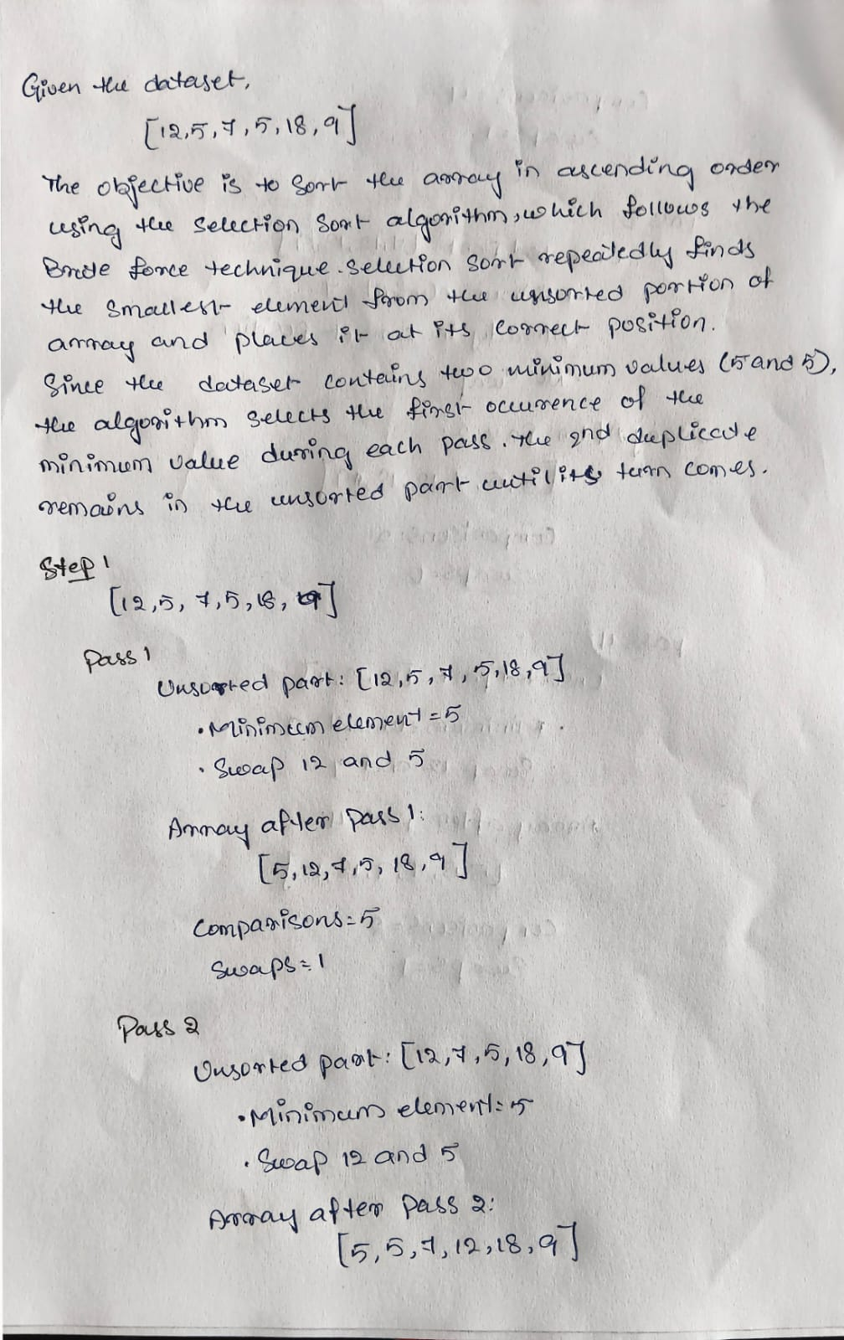
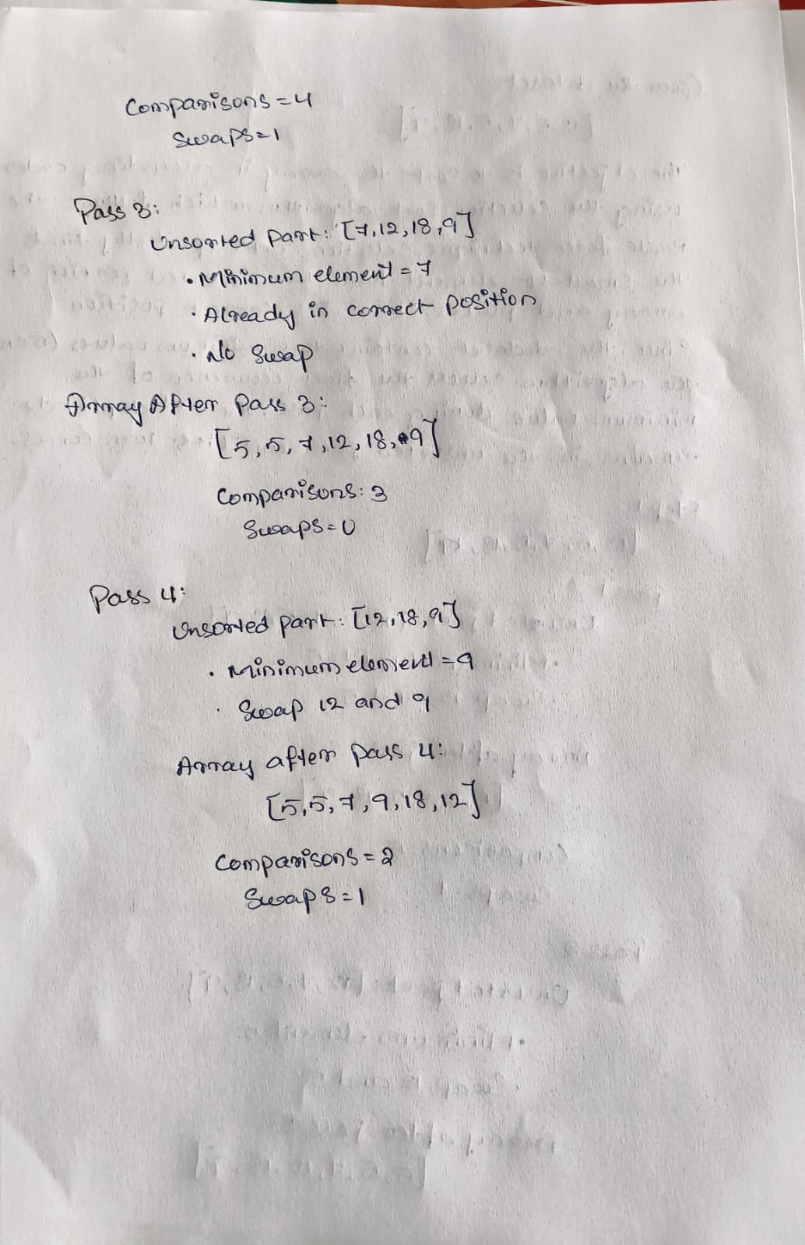
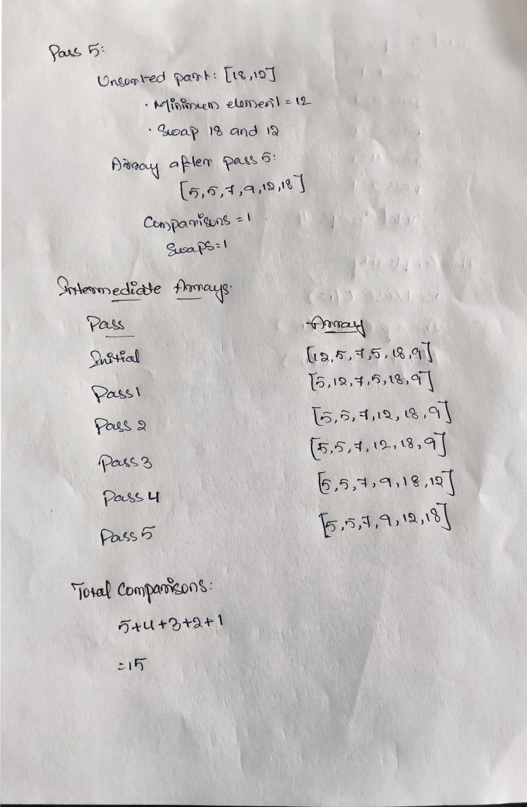
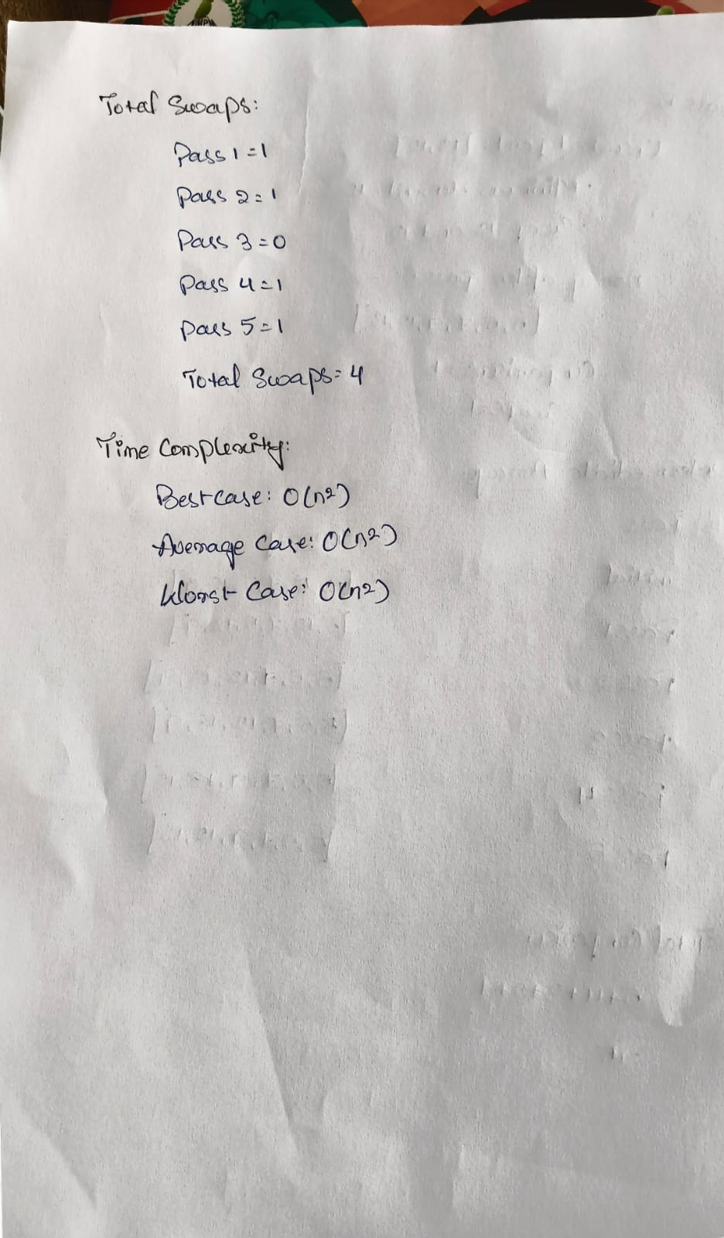

Code of Conduct
I M. Ranjith Kumar Reddy(192524172) (Name / Reg No) certify that this submission is my original work and that I have adhered to the guidelines specified for this assessment. I understand that any violation of academic integrity rules will result in disciplinary action.
Signature of the Student: 

RUBRICS FOR CALCULATION

Criteria | Wt. | Level 4 – Exemplary | Level 3 –  Proficient | Level 2 –  Developing | Level 1 –  Beginning
Understanding of Problem Context | 20% | Clearly understands the problem and accurately identifies all requirements | Good  understanding with minor gaps | Basic understanding; some requirements unclear | Poor  understanding or misinterpretation of the problem
Application of Concepts | 30% | Accurately applies appropriate concepts to solve complex problems | Applies relevant concepts correctly with minor errors | Applies basic concepts with limited accuracy | Fails to apply appropriate concepts
Problem-Solving Approach | 20% | Logical, well-structured, and efficient approach | Mostly logical approach with minor gaps | Basic approach with  some  inconsistencies | Illogical or  unclear approach
Accuracy of Solution | 20% | Completely correct solution with proper justification | Mostly correct with minor errors | Partially correct solution | Incorrect or incomplete solution
Clarity | 10% | Clear, well-organized, and properly explained solution | Understandable with minor clarity issues | Limited clarity and explanation | Poorly presented and difficult to understand

Marks Evaluation:
Question No. | Understanding of Problem  Context (20%) | Application of  Concepts  (30%) | ProblemSolving  Approach  (20%) | Accuracy  of  Solution  (20%) | Clarity (10%) | Total Marks
Q1 (40 Marks) | 4 | 4 | 4 | 4 | 4 | 40
Q2 (30 Marks) | 4 | 4 | 4 | 4 | 4 | 30
Q3 (30 Marks) | 4 | 3 | 3 | 2 | 2 | 22
 |  |  |  | Overall Total (100) |  | 92

Faculty In-charge | Course Coordinator | Head of Department
Signature: _______________ | Signature: _______________ | Signature: _______________
Date: ___________________ | Date: ___________________ | Date: ___________________

